**Methods: GP (Generalized Particle Methods)**

Back to Methods

“A fundamental concept of materials science is that the properties of materials flow from their atomic and microscopic structures”[ 1]. GP’s following features are developed based on this concept:

- GP is the unique concurrent multiscale method so far which keeps structures at all scales the same as the atomic scale (e.g. BCC, FCC).[2] Based on the GP concept of scale duality (Fig. 1) material elements can be high-scale particles in the n* * domain via an atom-lumping process for domains with smooth deformation gradient to save a lot of DOF. Its adaptive inverse top-down decomposition processes are automatically conducted if the domain deformation gradient becomes larger.

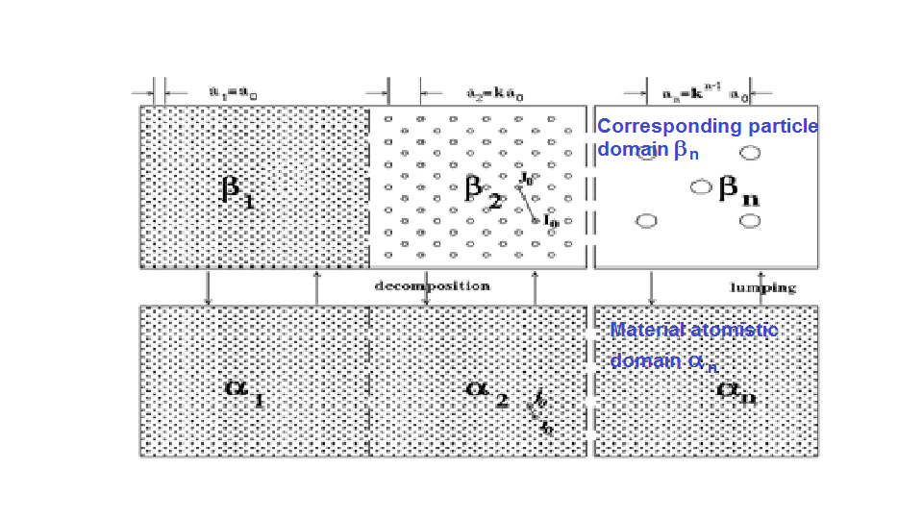 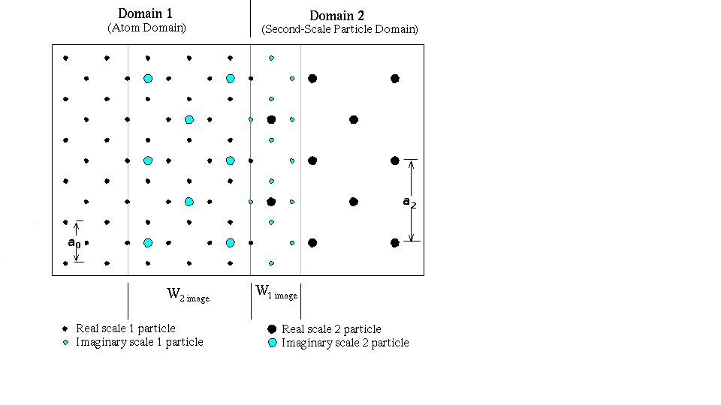

*Fig. 1. GP concept of scale duality & structures invariance Fig. 2. Bottom-up & top-down scale bridging*

*at all scales (n=1, 2..m) with n=1 being atomic scale are through NLC at scale interface Wnimage*

- GP has the same structure and the non-local constitutive behavior of atoms in both sides of the scale interface, thus no behavioral incompatibility will exist.[2,3] GP introduces two imaginary domains, W(*n*+1)image and W(*n*)image (Fig. 2), to make seamless transition across scale interface. It consists of imaginary particle near real particles. Imaginary particles' position is determined by the statistically averaging of the real atoms in NLC. This guarantee each domain has natural boundary for modeling.

- GP’s calculation in all particle scale can be conducted in the corresponding n  atomistic domain[3] by the proposed inverse mapping method based on the Cauchy-Born rule and the fact that all scales have the same material crystal structure. Thus the numerical method for GP is essentially an extension of MD with the same potential and can be easily incorporated into applications by modifying existing MD codes.

- GP can also have linkage with FE mesh It only appears in the remote particle domain far from the atomistic scale boundary to avoid ghost force. In addition, the scale bridging does not use the DC method but using WG (or WF) domain’s particle averaging to have bottom-up transition, etc. as did by W(n)imag.

- GP has wide applications currently and potentially: Nanoscale coatings, interfacial stress and fracture Behavior[3]; Defect nucleation and evolutions;[2,4] Crack-tip elastic and inelastic behavior[5], Accuracy verification methods of multiscale methods.[6]